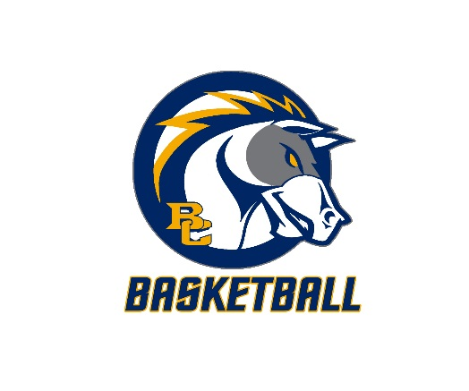**Briar Cliff Chargers**

**2022 Boys Basketball Camp**

**Briar Cliff University**

**Sioux City, Iowa**

**June 6-8 Fundamentals Day Camp Grades 3-8**

**Camp Program**

The Chargers’ Basketball Camp is designed to focus on fundamentals, particularly offensive fundamental skills. It is our goal that participants gain improved basketball skills and become excited about basketball.

**Camp Director**

Mark Svagera, head men’s basketball coach at Briar Cliff University will direct the Chargers’ 2022 Boys Basketball Camp. Coach Svagera is entering his 6th season as head coach at Briar Cliff. Coming off a GPAC Championship and National tournament appearance this past year, Coach Svagera has a career record of 95-57 and 2 NAIA Elite Eight appearances. He brings a wealth of camp experience to this Fundamentals Camp.

**Camp Features**

•Free camp T-Shirt

•Skill development stressed throughout camp

•Full court games against players at similar levels

•Campers will be coached by coaches and college players

•Several camp awards

**Camp Cost and Times**

$90 per individual……….9 a.m. to Noon

**Camp Gear**

Bring your own practice clothes, basketball shoes and your enthusiasm!

There will be Gatorades, Waters, and Candy Bars available for purchase at break.

**Insurance**

Campers must be covered by their family insurance policy. Briar Cliff University is not responsible for injuries.

**Questions**

Contact: Coach Mark Svagera at (712) 279-5441 or mark.svagera@briarcliff.edu

Coach Bryan Forbes at (712) 279-5513 or bryan.forbes@briarcliff.edu

**REGISTRATION**

*(Registration deadline to guarantee enrollment is June 1)*

To register for Chargers’ 2022 Boys’ Basketball Camp, complete this form and the Parent/Guardian Release & Indemnity Agreement and mail to address below.

Name_____________________________________Phone_______________________________

Address_________________________________City________________State______Zip______

Email____________________________________Grade Next Year 3 4 5 6 7 8

T Shirt Size (Circle One) YS YM YL S M L XL XXL

Cost: $100

Note: Cancellations will be refunded all but a $20 processing fee.

**Parent/Guardian Release & Indemnity Agreement**

To: 2022 Briar Cliff University Chargers’ Boys’ Basketball Camp

We (or I) hereby request that you accept the application for enrollment of __________________ in the 2022 Briar Cliff University Chargers Boys Basketball Camp (“Camp”) during the dates set forth in this application. In consideration of your acceptance of this application, we/I, whether one or more, hereby release the Board of Trustees and employees of Briar Cliff University from any claims arising from injuries which may be sustained by our (or my) child while attending the Camp; and we/I agree to indemnify the Board of Trustees and employees of Briar Cliff University from any claims which may hereafter arise as a result of injuries sustained by our/my child while attending the Camp

Signed_____________________________________________________________

Date____________________Phone______________________________________

*Make checks for $90 payable to*

BRIAR CLIFF MEN’S BASKETBALL

*Send registration and payment to*

Mark Svagera, Basketball Camp

Briar Cliff University

3303 Rebecca Street

Sioux City, Iowa 51104